Workshop Planning template
The following template can be used as a guide in developing workshops within learning tracks/programs. Feel free to modify this template to suit your development needs.
Complete this form for your workshop planning & share it with your cic
Which Youth Program is this Workshop for?
______ 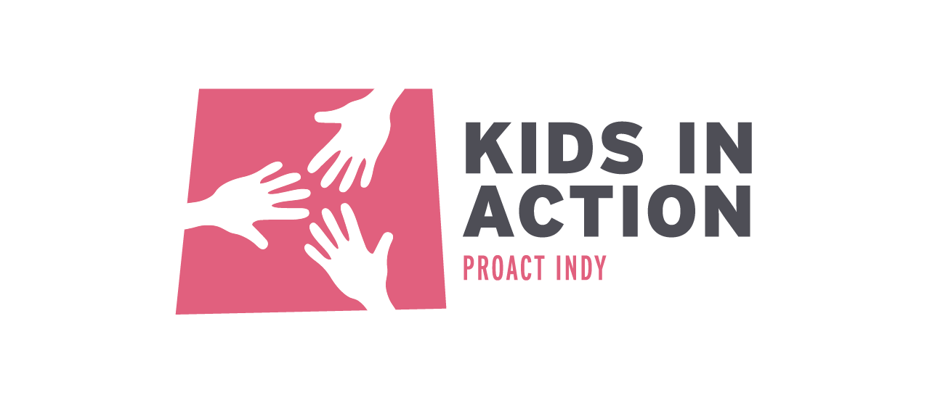 ______ 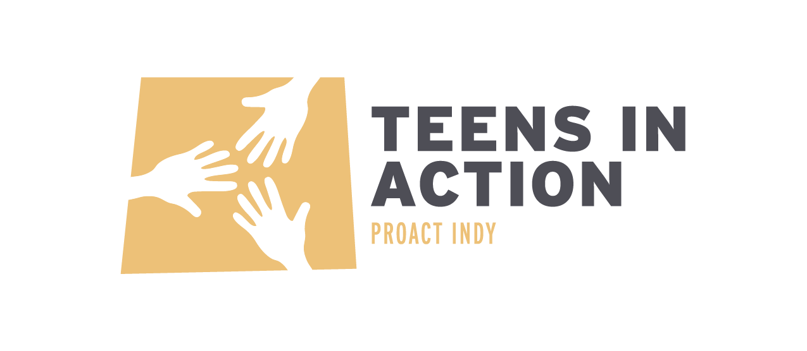
Workshop title:
Learning outcomes (optional):
Delivery mode: _____ In-Person _____ Virtual
Focus area (Social Issue):
Description:
*Below is where specific planning information for developer/facilitator use can be included.
Workshop developers:
Workshop facilitator(s): (may want to have a backup facilitator in case of emergency)
# of Participants:
Materials Needed (if any):
Procedure/Agenda (who, what, when, where):
Activity Type | Activity Name | Who will Lead?
Check In/Introduction
Recite ProAct Mission & Values | Recite ProAct Mission & Values
Icebreaker or Team Building Activity
Main Lesson Activity (Review service project, Guest Speaker, Game, etc.)
Reflection Activity

Link to participant feedback survey (if applicable):

